# Data Centric RAD

## Lab 10 JSF with Database

### Setting up a JSF Project

* Open Eclipse Java EE IDE for Web Developers.
* Select *File/New/Other/Web/Dynamic Web Project*.
* Enter a project name and select the Target runtime as shown:

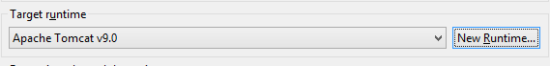

* + If there are no options, press *New Runtime*
  + Click on Apache Tomcat v9.0 and press *Next*
  + Browse to the Apache Tomcat installation directory and press *Finish*

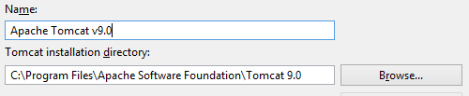

* Press *Modify* in the Configuration section:

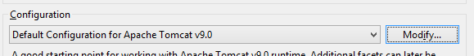

* On the *Project Facets* window select JavaServer Faces 2.2 and press *OK*.

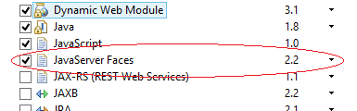

* Press *Next* until the *Web Module* screen appears, select the *Generate web.xml deployment descriptor* and press *Next*.

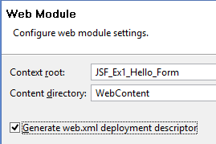

* On the *JSF Capabilities* screen, press the *Download library* button.

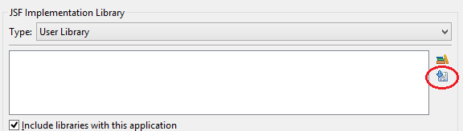

* Select the *JSF 2.2* screen, then press the *Next* followed by *Finish*.

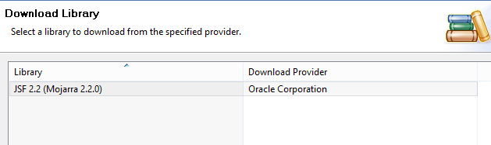

* Press *Finish* on the *JSF Capabilities* window.
* Download MySQL JDBC Driver from <http://dev.mysql.com/downloads/mysql/> unzip it and put the Jar file in the WEB-INF/lib folder of your application.
* Create a new file called *context.xml* in the *WebContent/META-INF/* folder and add the following to it:

<Context>

<Resource name="jdbc/employeesdb14"

auth="Container" type="javax.sql.DataSource"

maxActive="20" maxIdle="5" maxWait="10000"

username="root" password=""

driverClassName="com.mysql.jdbc.Driver"

url="jdbc:mysql://localhost:3306/employeesdb14"/>

</Context>

* Add the following to the *web.xml* file in *WebContent/WEB-INF/*:

<resource-ref>

<description>EmployeesDB Datasource</description>

<res-ref-name>jdbc/employeesdb14</res-ref-name>

<res-type>javax.sql.DataSource</res-type>

<res-auth>Container</res-auth>

</resource-ref>

### Part 1 Product Details

* Download and import *employeesDB14.sql* from Moodle.
* Write a JSF/JDBC application that queries the *product* table in the *employees* database and displays the first 3 products on a web page.

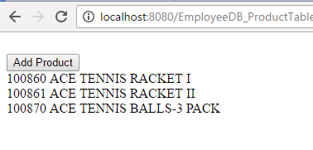

* The web page should have a button called *Add Product* that allows the user to enter details of a new product and add this product to the database.

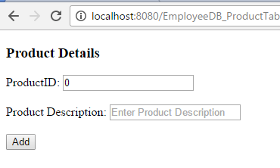

* If no Product ID is entered an error message must be displayed.

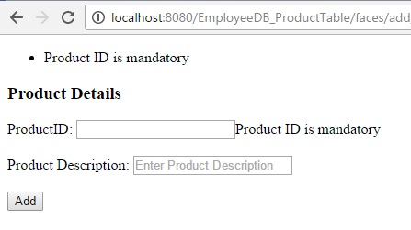

* If a Product ID is entered that already exists, an error message must be displayed.

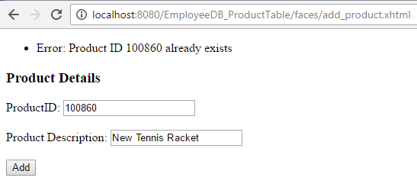

* If a Product is successfully entered, the user should be brought back to the main page where the list of the first 3 products is shown.

